**Requirement & Design Specification**

**Restaurant Management System (RMS)**

Subject: SWD392 Version: 1.0

– Danang, January 2025 –

**Record of Changes**

|  |  |  |  |  |
| --- | --- | --- | --- | --- |
| Version | Date | A* M, D | In charge | Change Description |
| V1.0 | 12/1/2025 | A |  |  |
|  |  |  |  |  |
|  |  |  |  |  |
|  |  |  |  |  |
|  |  |  |  |  |
|  |  |  |  |  |
|  |  |  |  |  |

*A - Added M – Modified D – Deleted

Contents

[I. Requirement Specification 4](https://docs.google.com/document/d/11x_8xUEvo9mXACGtZM3CjkL_jbVPOQO0XCYEOaDRJ4U/edit?fbclid=IwY2xjawH1ZYlleHRuA2FlbQIxMAABHQ0w_VSprt4EMtsVwqwAYkqIxSrCi5GiDXfgQeptj3TpDfnEC8eAmSP4rw_aem_dVXH9T5gynal-KcfwEtcww#heading=h.gjdgxs)

[I.1 Problem desciption 4](https://docs.google.com/document/d/11x_8xUEvo9mXACGtZM3CjkL_jbVPOQO0XCYEOaDRJ4U/edit?fbclid=IwY2xjawH1ZYlleHRuA2FlbQIxMAABHQ0w_VSprt4EMtsVwqwAYkqIxSrCi5GiDXfgQeptj3TpDfnEC8eAmSP4rw_aem_dVXH9T5gynal-KcfwEtcww#heading=h.gjdgxs)

[I.2 Major Features 5](https://docs.google.com/document/d/11x_8xUEvo9mXACGtZM3CjkL_jbVPOQO0XCYEOaDRJ4U/edit?fbclid=IwY2xjawH1ZYlleHRuA2FlbQIxMAABHQ0w_VSprt4EMtsVwqwAYkqIxSrCi5GiDXfgQeptj3TpDfnEC8eAmSP4rw_aem_dVXH9T5gynal-KcfwEtcww#heading=h.30j0zll)

[I.3 System Context 10](https://docs.google.com/document/d/11x_8xUEvo9mXACGtZM3CjkL_jbVPOQO0XCYEOaDRJ4U/edit?fbclid=IwY2xjawH1ZYlleHRuA2FlbQIxMAABHQ0w_VSprt4EMtsVwqwAYkqIxSrCi5GiDXfgQeptj3TpDfnEC8eAmSP4rw_aem_dVXH9T5gynal-KcfwEtcww#heading=h.1fob9te)

[I.4 Non-Functional Requirements 11](https://docs.google.com/document/d/11x_8xUEvo9mXACGtZM3CjkL_jbVPOQO0XCYEOaDRJ4U/edit?fbclid=IwY2xjawH1ZYlleHRuA2FlbQIxMAABHQ0w_VSprt4EMtsVwqwAYkqIxSrCi5GiDXfgQeptj3TpDfnEC8eAmSP4rw_aem_dVXH9T5gynal-KcfwEtcww#heading=h.3znysh7)

[I.5 Functional Requirements 13](https://docs.google.com/document/d/11x_8xUEvo9mXACGtZM3CjkL_jbVPOQO0XCYEOaDRJ4U/edit?fbclid=IwY2xjawH1ZYlleHRuA2FlbQIxMAABHQ0w_VSprt4EMtsVwqwAYkqIxSrCi5GiDXfgQeptj3TpDfnEC8eAmSP4rw_aem_dVXH9T5gynal-KcfwEtcww#heading=h.1t3h5sf)

[**I.5.1 Usecase Diagram** 13](https://docs.google.com/document/d/11x_8xUEvo9mXACGtZM3CjkL_jbVPOQO0XCYEOaDRJ4U/edit?fbclid=IwY2xjawH1ZYlleHRuA2FlbQIxMAABHQ0w_VSprt4EMtsVwqwAYkqIxSrCi5GiDXfgQeptj3TpDfnEC8eAmSP4rw_aem_dVXH9T5gynal-KcfwEtcww#heading=h.4d34og8)

[**I.5.2 UC Specifications** 16](https://docs.google.com/document/d/11x_8xUEvo9mXACGtZM3CjkL_jbVPOQO0XCYEOaDRJ4U/edit?fbclid=IwY2xjawH1ZYlleHRuA2FlbQIxMAABHQ0w_VSprt4EMtsVwqwAYkqIxSrCi5GiDXfgQeptj3TpDfnEC8eAmSP4rw_aem_dVXH9T5gynal-KcfwEtcww#heading=h.lnxbz9)

[**I.5.3 Activity Diagram** 38](https://docs.google.com/document/d/11x_8xUEvo9mXACGtZM3CjkL_jbVPOQO0XCYEOaDRJ4U/edit?fbclid=IwY2xjawH1ZYlleHRuA2FlbQIxMAABHQ0w_VSprt4EMtsVwqwAYkqIxSrCi5GiDXfgQeptj3TpDfnEC8eAmSP4rw_aem_dVXH9T5gynal-KcfwEtcww#heading=h.1ksv4uv)

**I. Requirement Specification**

**I.1 Problem desciption**

Previously, restaurants relied heavily on manual processes for taking orders and communicating between staff and the kitchen, which often resulted in longer wait times and frequent order errors. These issues not only reduced operational efficiency but also negatively impacted the customer experience, leading to dissatisfaction and fewer repeat customers. The system was created to address these issues. By automating the order taking process and providing real-time communication between servers and kitchen staff, the system reduces wait times and minimizes the risk of order errors. In addition, the system improves the customer experience by providing accurate, fast service and customizable menu options.

Currently in Vietnam, systems such as POS365 and iPOS have been introduced to improve customer experience as well as modernize restaurant processes, however, these two systems only target the dine-in customer segment and do not focus on the online reservation customer segment, which is difficult to reach for small and medium-sized restaurants. Nowadays, people can view menus online. That way, whether they are dining in or ordering food out, they can choose their food and pay faster and easier. Almost everyone searches online to research businesses before patronizing them in this day and age.  People like to know what menu options are available before they visit a restaurant. Online menus make it easier for restaurants to gain more customers. “The easier it is for customers to order from your restaurant, the more likely they are to choose your restaurant over your competitors,” CloudKitchens.com emphasizes, “Think about when you’re about to make an online purchase, if there are too many steps along the way, you’re more likely to go elsewhere.”

Take advantage of the system complete online ordering software solution! Easily set up your menu, update it live, handle online and takeout reservations, schedule orders and reservations, generate promo codes, and more!

The system is designed to serve a wide range of users, from restaurant owners and managers to waitstaff, kitchen teams and customers. For restaurant owners and managers, the system provides an intuitive platform that streamlines order management, monitors revenue, and enhances overall operational efficiency.  As for restaurant employees, SRMMS supports them by offering essential tools that simplify daily tasks, from handling and tracking orders to ensuring seamless communication between different departments. For customers, the system also provides an online menu feature via QR code placed at the table, minimizing contact and increasing accuracy and speed when customers choose dishes. With this online menu, customers can also know the exact amount of calories in each specific dish to balance their diet according to their needs. The system delivers a more convenient and personalized experience, allowing customers to easily place orders and receive dish recommendations tailored to cusstomer's preferences and dining history. This not only enhances satisfaction but also makes every restaurant visit more enjoyable and memorable.

With the above objectives, the system is not only a management improvement tool but also a means to enhance customer experience, thereby promoting growth and sustainable development for restaurants. In the future, this system will be an ideal solution for small and medium-sized restaurants, customizable to suit the specific needs of each restaurant while ensuring operational efficiency, resource optimization and cost efficiency.

**Strategic Goals:**

● Efficiency: Automate repetitive tasks, allowing restaurant staff to focus on providing high-quality service.

● Scalability: Support restaurants from small to medium, ensuring the system can scale as restaurants grow.

● Customer Focus: Deliver the best customer experience by optimizing interactions between customers and restaurants through smart ordering features and personalized dish recommendations.

This product will become an essential tool for any restaurant looking to optimize operations, enhance customer experience, and increase business profitability.

**I.2 Major Features**

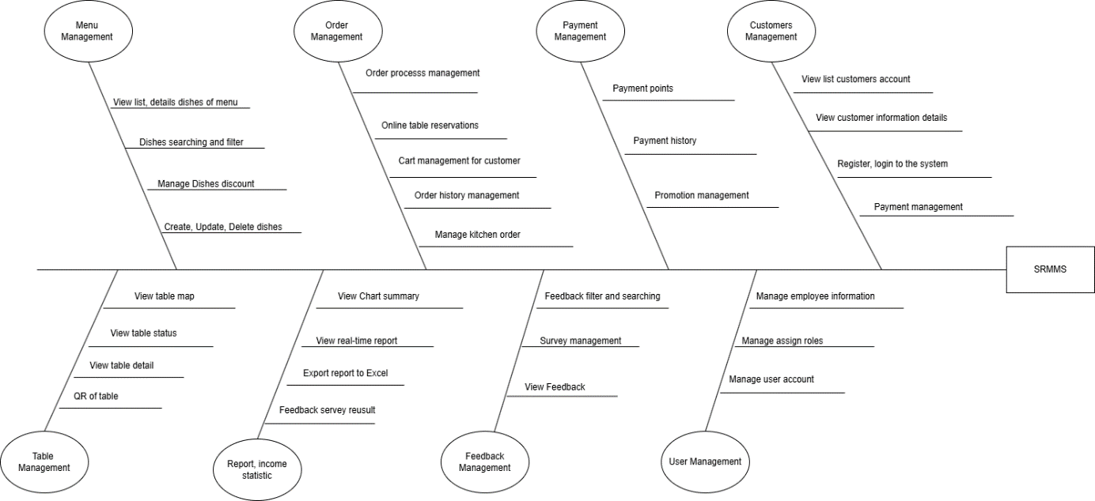

|  |  |
| --- | --- |
| ***ID*** | ***Feature & Description*** |
| *FE-01* | ***Manage Login***  *Register to system with phone number*  *Login to system with username/ password* |
| *FE-02* | ***Manage Order***  *Choose table available, ordering*  *View order history.* |
|  |  |
| *FE - 03* | ***Manage Cart***  *Add dishes to cart.*  *Update Cart.*  *Delete from cart.* |
| *FE-04* | ***Manager Menu:***  *Create new dishes.*  *Filter by category product.*  *Update general information about dishes.*  *View list of dishes.*  *Filter dishes by categories and prices.*  *Search dishes by name.*  *View details of dishes*  *Delete dishes.* |
|  |  |
| *FE-05* | ***Manage confirm and process order***  *Confirm new orders.*  *Online table reservation.*  *Confirm, order and payment*  *Update orders statuses.* |
| *FE-06* | ***Manage order payments***  *Confirm payment.*  *Send payment notifications.*  *Add discount code.* |
| *FE-07* | ***View order history.***  *View completed order details.*  *Export order report.* |
|  |  |
| *FE-8* | ***Manage emloyees information***  *View list of employees.*  *Search employees by name.*  *Search employees by phone number.*  *Add new employees.*  *Delete employees.*  *Update personal information* |
| *FE-9* | ***Manage kitchen orders***  *View list of orders to be processed.*  *Confirm dish completion.* |
| *FE-10* | ***Manage Table***  *View table map*  *View table status*  *View details table (ID, Name, map, active-inactive, Status )* |
| *FE-11* | ***Manage User***  *View list user.*  *View details user.*  *Add payment points.*  *Search user by phone number.*  *Delete user.*  *View payments points.*  *Edit payment points.* |
| *FE-12-* | ***Manage user accounts***  *Add new user accounts.*  *Active user of employees.*  *Inactive users of employees.*  *Update personal information.*  *Edit user information*  *Delete user accounts.* |
| *FE-13* | ***Report, income statistics.***  *View Chart summary*  *View reports by day, month, year*  *View detailed invoice*  *Export report to Excel*  *View food chart by order quantity* |

**I.3 System Context**

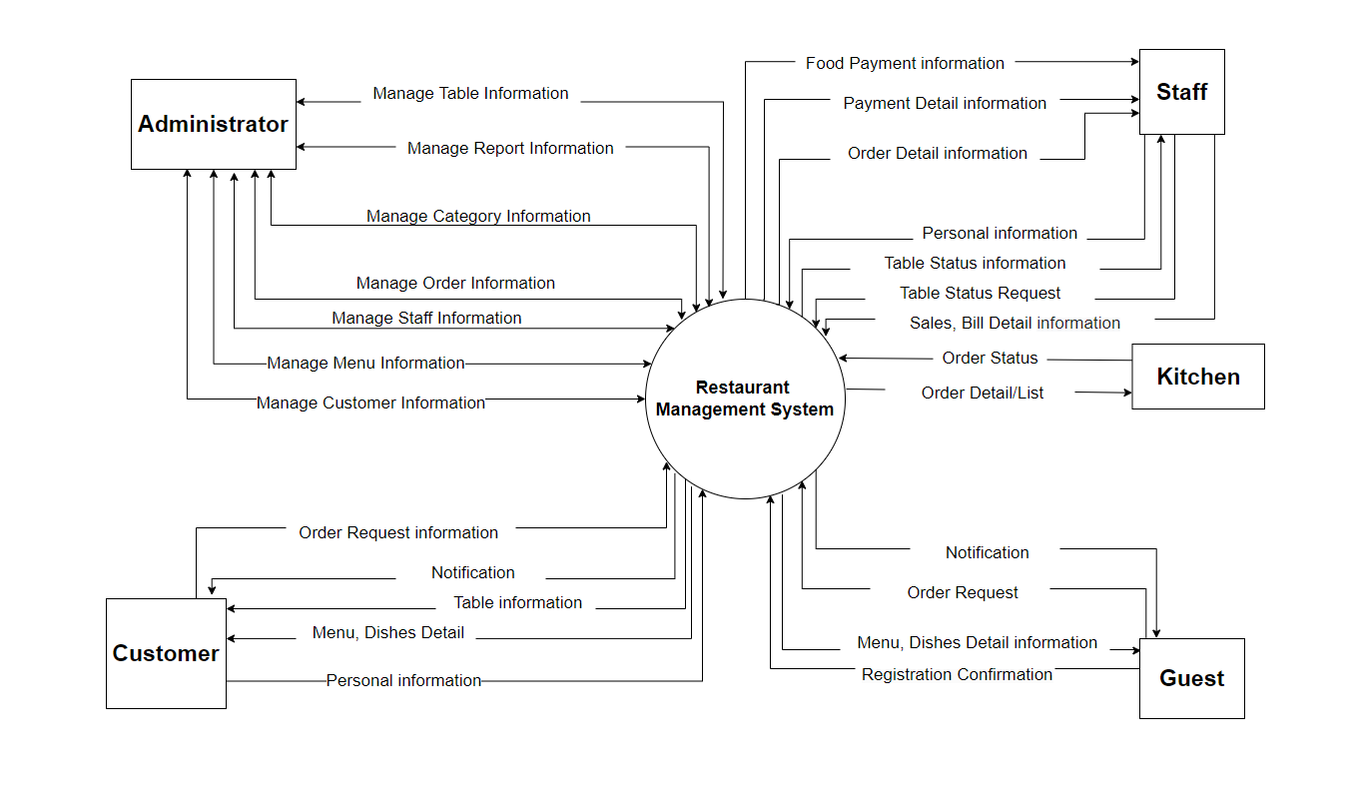

|  |  |  |
| --- | --- | --- |
| **#** | **Actor** | **Description** |
| 1 | Administrator | The web administrator is responsible for managing user accounts and managing system notifications, this person is the restaurant owner and is also responsible for managing dishes on the menu, can add, edit, delete dishes as well as manage tables, manage customers, manage statistical reports. |
| 2 | Kitchen | The kitchen Admin is assigned by the administrator, this person is responsible for receiving customer orders. After confirmation, this person will return to the customer the status of the dish that the customer has ordered. |
| 3 | Staff | The waiter is assigned by the administrator, this person is responsible for receiving the customer's order. After the customer finishes eating, ask this person to come to pay and the waiter can see what the customer ordered. |
| 4 | Guest | User not login in system, Guest need to scan the QR code on the table and fill in the information to see the menu |
| 5 | Customer | After scanning the QR code and filling in personal information, customers will be able to use all the restaurant's services such as viewing the menu, placing orders, and seeing how the order is completed,... |

**I.4 Non-Functional Requirements**

**User Interfaces**

* UI-01: The web application will work smoothly on these: Chrome, Firefox, Safari, and Edge.
* UI-02: The web application  is suitable for all different users and is friendly.
* UI-03: All error messages should be clear and can provide troubleshooting guidance to the user.
* UI-04: The application supports English only.

**External Interfaces**

* EI-01: System will support most web browsers with responsive design.
* EI-02: All data must be integrated via API.
* EI-03: Response API uses JSON format.

**Quality Attributes**

* US-01: Users will quickly grow used to and productive at core operations.
* US-02: Error and warning messages are simple.
* US-03: Prominent board and card features. The board and card features should be prominent and easy to use.
* Reliability
* RE-01: Before being sent to the server, every information submitted by the user is verified.
* RE-02: The system complies with business rules.
* Performance
* PE-01: Data will be stored on a good-performance server.
* PE-02: Optimize query statements.
* PE-03: The response time of the functions in the system is less than 4 seconds.
* Security
* SE-01: Depending on the role of the user, the corresponding screen will be displayed.
* SE-02: The database will be safely kept on the server.

**I.5 Functional Requirements**

**I.5.1 Usecase Diagram**

***I.5.1.1 UCs for Admin***

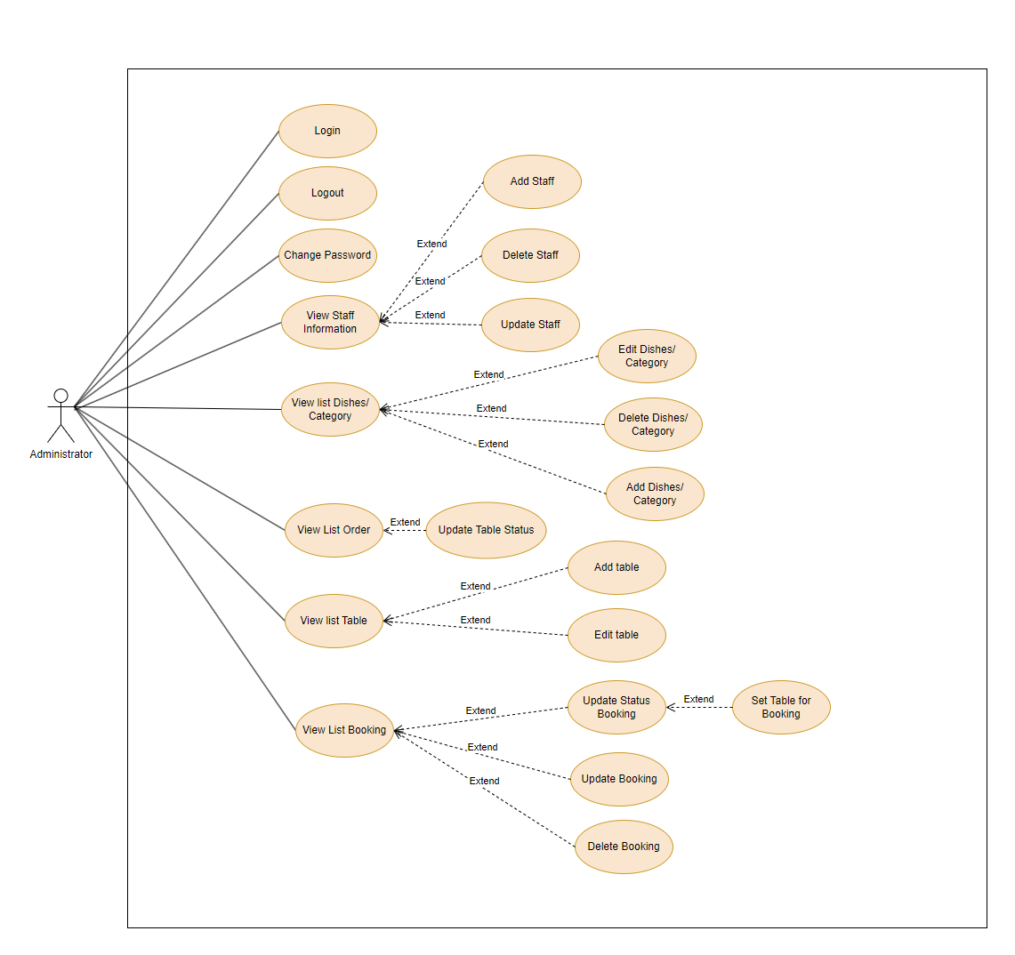

***I.5.1.2 UCs for Guest***

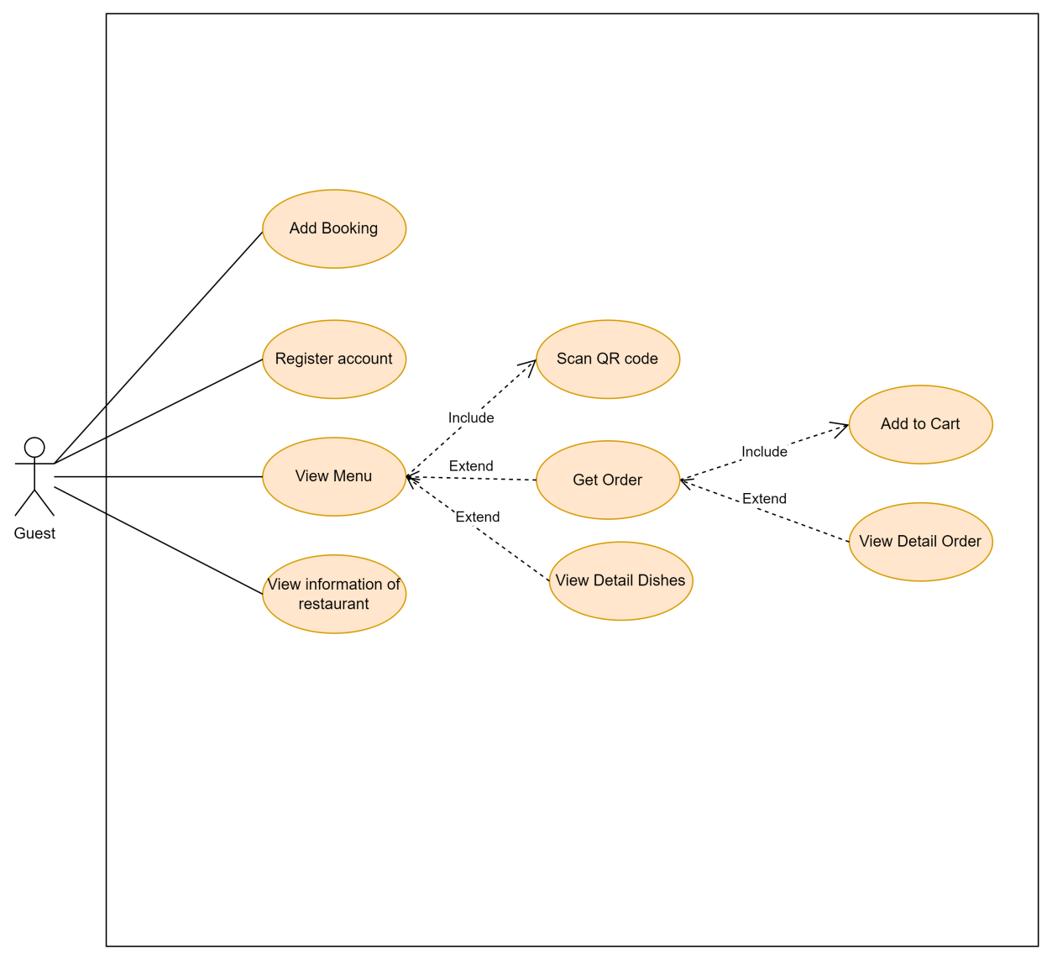

***I.5.1.3 UCs for Customer***

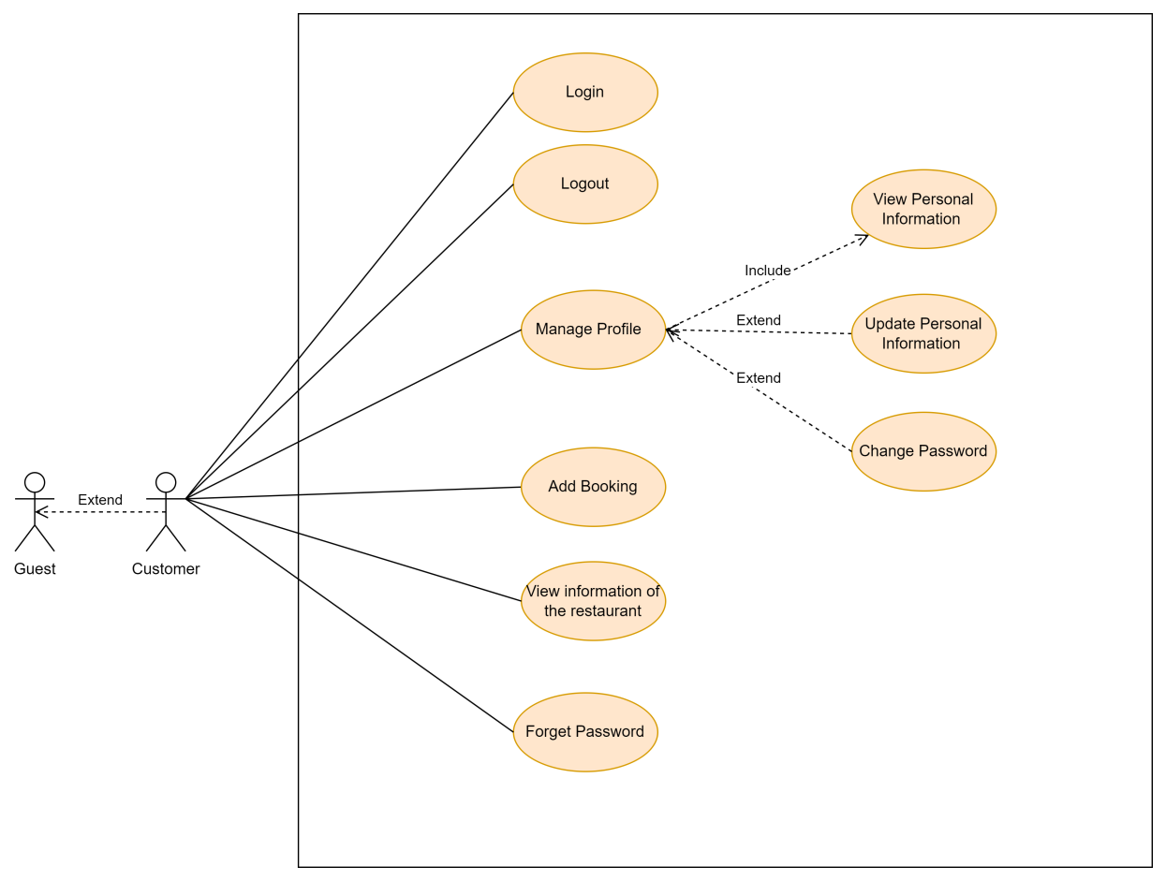

***I.5.1.4 UCs for Staff***

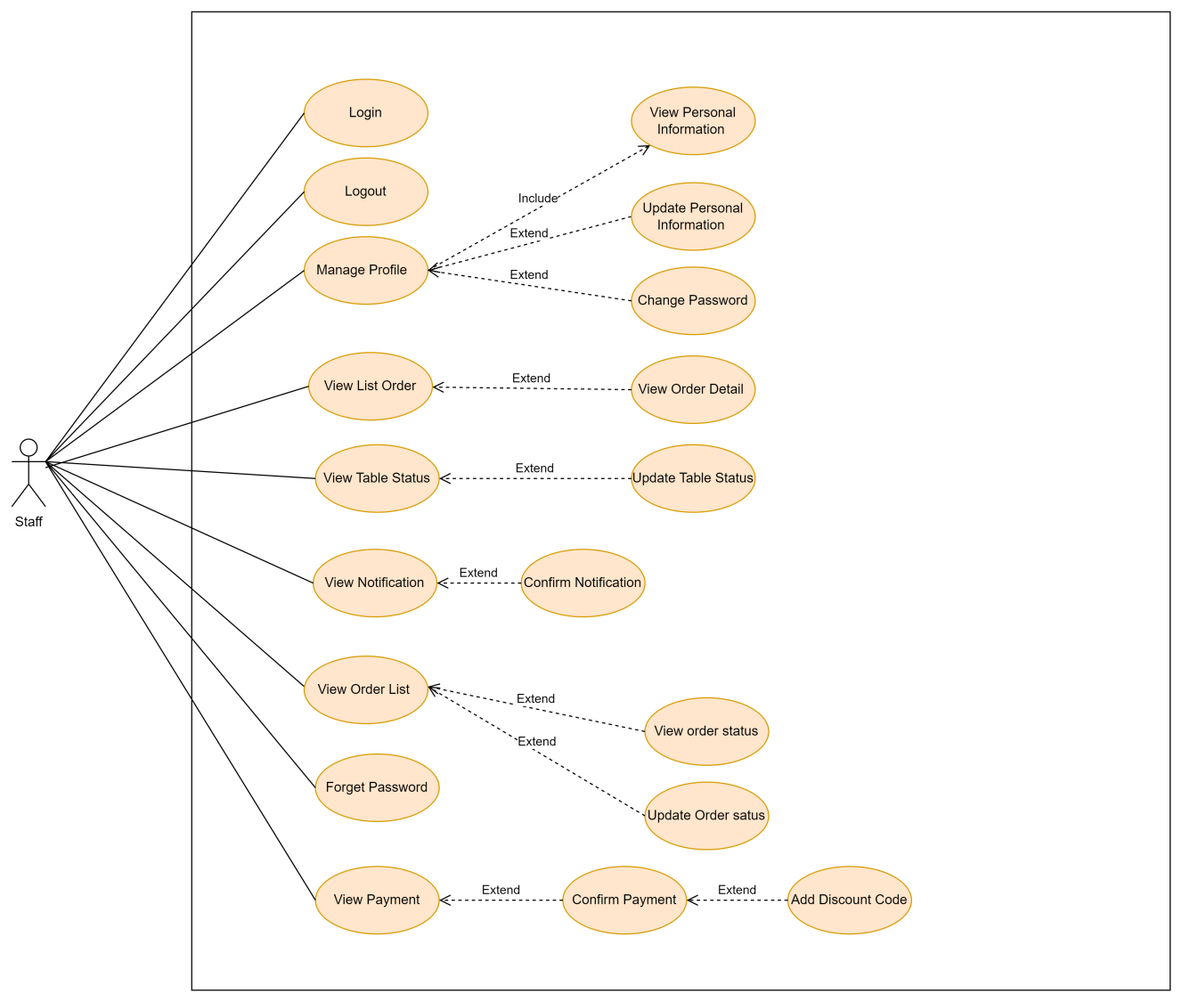

**I.5.2 UC Specifications**

|  |  |  |  |
| --- | --- | --- | --- |
| UC ID and Name: | ***Create new categories*** | | |
| Created By: |  | Date Created: |  |
| Primary Actor: | Admin | Secondary Actors: | N/A |
| Trigger: | Admin wants to create new dishes in the system. | | |
| Description: | As a Admin, I want to create categories in the system | | |
| Preconditions: | The system is running without any technical issues and is capable of processing new categories entries.  The interface for managing categories is accessible and fully functional for data input. | | |
| Postconditions: | The new dish category is saved in the system database with all relevant details  The new dish category appears on the restaurant menu and is available for customers to choose from.  Relevant roles (e.g. kitchen staff, Administrator) are notified of the new category being added to the menu  The system continues to function normally without any data inconsistencies or errors caused by the new dish category entry. | | |
| Normal Flow: | 1. Navigates to the "Create a categories" section. 2. The system displays a form for entering categories details. 3. The role Admin fills in the required categories information 4. The role Admin submits the form to create the categories. 5. The system validates the submitted information (e.g., checks for completeness, correct format, uniqueness of categories name). 6. If the information is valid, the system creates a new categories record in the database. 7. The system confirms the successful creation of the categories, displaying the new categories details. | | |
| Alternative Flows: | **Step 4: Incomplete or Incorrectly Formatted Categories Information**  If the submitted categories information (e.g., name, price, ingredients) is incomplete or incorrectly formatted, the system prompts the Admin to correct the errors and resubmit the form.  Duplicate categories Name: If the categories name already exists in the system, the system alerts the Admin and prompts them to choose a different, unique name. | | |
| Exceptions: | **Step 7: Network or System Failure**  If the creation or role assignment process encounters an error (e.g., due to network issues), the system should inform the role Admin and allow them to retry. | | |
| Priority: | Medium | | |
| Frequency of Use: | Medium | | |
| Business Rules: | N/A | | |
| Other Information: | N/A | | |
| Assumptions: | The role Admin has the appropriate permissions and access to create new dishes  and manage role assignments.  The dishes to be created do not already exist and the role assignments are valid.  The system has mechanisms for validating, storing new dishes information, and managing role assignments.  The role Admin has reviewed and confirmed all details before submission. | | |

|  |  |  |  |
| --- | --- | --- | --- |
| UC ID and Name: | ***Update categories*** | | |
| Created By: |  | Date Created: |  |
| Primary Actor: | Admin | Secondary Actors: | N/A |
| Trigger: | Admin wants to create new dishes in the system. | | |
| Description: | As a Admin, I want to update categories in the system | | |
| Preconditions: | The system is running without any technical issues and is capable of processing  update categories entries.  The interface for managing categories is accessible and fully functional for data input. | | |
| Postconditions: | The update information dish category is saved in the system database with all relevant details  The system continues to function normally without any data inconsistencies or errors caused by the new dish category entry. | | |
| Normal Flow: | Click “Category” tab  Redirect to “Category” page and list all information of categories  Click “Edit” button  Redirect to “Edit Category” page and list all information field of category to edit  Edit information and then click the “Save” button  The system validates the submitted information (e.g., checks for completeness, correct format, uniqueness of categories name).  If the information is valid, the system save update categories information record in the database.  The system confirms the successful update of the categories, displaying the edited categories details. | | |
| Alternative Flows: | **Step 4: Incomplete or Incorrectly Formatted Categories Information**  If the submitted categories information (e.g., name, price, ingredients) is incomplete or incorrectly formatted, the system prompts the Admin to correct the errors and resubmit the form.  Duplicate categories Name: If the categories name already exists in the system, the system alerts the Admin and prompts them to choose a different, unique name. | | |
| Exceptions: | **Step 7: Network or System Failure**  If the creation or role assignment process encounters an error (e.g., due to network issues), the system should inform the role Admin and allow them to retry. | | |
| Priority: | Medium | | |
| Frequency of Use: | Medium | | |
| Business Rules: | N/A | | |
| Other Information: | N/A | | |
| Assumptions: | The role Admin has the appropriate permissions and access to create new dishes  and manage role assignments.  The dishes to be created do not already exist and the role assignments are valid.  The system has mechanisms for validating, storing new dishes information, and managing role assignments.  The role Admin has reviewed and confirmed all details before submission. | | |

|  |  |  |  |
| --- | --- | --- | --- |
| UC ID and Name: | ***Enable/Disable category*** | | |
| Created By: |  | Date Created: |  |
| Primary Actor: | Admin | Secondary Actors: | N/A |
| Trigger: | Admin wants to enables/disables category in the system Menu | | |
| Description: | As a Admin, I want to enables/disables categories in the system Menu | | |
| Preconditions: | The system is running without any technical issues and is capable of processing enabled/disabled category entries.  The interface for managing categories is accessible and fully functional for data input. | | |
| Postconditions: | Edited dish categories enabled/disabled on user's Menu  The system continues to function normally without any data inconsistencies or errors caused by the new dish category entry. | | |
| Normal Flow: | Click “Category” tab  Redirect to “Category” page and list all information of categories  Click “Delete” button  Click the “Save” button  The system confirms the successful update of the categories, displaying the edited categories details. | | |
| Alternative Flows: | N/A | | |
| Exceptions: | **Step 7: Network or System Failure**  If the creation or role assignment process encounters an error (e.g., due to network issues), the system should inform the role Admin and allow them to retry. | | |
| Priority: | Medium | | |
| Frequency of Use: | Medium | | |
| Business Rules: | N/A | | |
| Other Information: | N/A | | |
| Assumptions: | The role Admin has the appropriate permissions and access to create new dishes  and manage role assignments.  The dishes to be created do not already exist and the role assignments are valid.  The system has mechanisms for validating, storing new dishes information, and managing role assignments.  The role Admin has reviewed and confirmed all details before submission. | | |

|  |  |  |  |
| --- | --- | --- | --- |
| UC ID and Name: | ***Search categories*** | | |
| Created By: |  | Date Created: |  |
| Primary Actor: | Admin, Customer, Guest | Secondary Actors: | N/A |
| Trigger: | Admin wants to search for dishes by category | | |
| Description: | I want to create categories in the system | | |
| Preconditions: | The system is running without any technical issues and is capable of handling new category entries.  Existing dishes and categories for users to access | | |
| Postconditions: | The categories of dishes that appear on the restaurant menu and that customers can choose from. | | |
| Normal Flow: | User Selects Menu  User enters the food category they want to search for  System displays the food category and a list of dishes in that category | | |
| Alternative Flows: | **Step 2: Incomplete Category Information**  If the submitted category information (e.g. name) is incomplete or incorrectly formatted, the system will not display the search result information | | |
| Exceptions: | **Step 3: Network or System Failure**  If the creation or role assignment process encounters an error (e.g., due to network issues), the system should inform the role Admin and allow them to retry. | | |
| Priority: | Medium | | |
| Frequency of Use: | Medium | | |
| Business Rules: | N/A | | |
| Other Information: | N/A | | |
| Assumptions: | N/A | | |

|  |  |  |  |
| --- | --- | --- | --- |
| UC ID and Name: | ***List of categories*** | | |
| Created By: |  | Date Created: |  |
| Primary Actor: | Admin, Customer, Guest | Secondary Actors: | N/A |
| Trigger: | User wants to view list of  category | | |
| Description: | As a user, I want to see a categorized list of dishes so I can easily choose. | | |
| Preconditions: | The system is running without any technical issues and is capable of handling new category entries.  Existing dishes and categories for users to access | | |
| Postconditions: | The categories of dishes that appear on the restaurant menu and that customers can choose from. | | |
| Normal Flow: | User selects Menu  User selects to view food categories  System displays food categories and list of dishes in that category | | |
| Alternative Flows: | **Step 2: Incomplete Category Information**  If the submitted category information (e.g. name) is incomplete or incorrectly formatted, the system will not display the search result information | | |
| Exceptions: | **Step 3: Network or System Failure**  If the creation or role assignment process encounters an error (e.g., due to network issues), the system should inform the role Admin and allow them to retry. | | |
| Priority: | Medium | | |
| Frequency of Use: | Medium | | |
| Business Rules: | N/A | | |
| Other Information: | N/A | | |
| Assumptions: | N/A | | |

|  |  |  |  |
| --- | --- | --- | --- |
| UC ID and Name: | ***Create new dishes*** | | |
| Created By: |  | Date Created: |  |
| Primary Actor: | Admin | Secondary Actors: | N/A |
| Trigger: | Admin wants to create new dishes in the system. | | |
| Description: | As a Admin, I want to create new dishes in the system, including assigning roles and permissions specific to those dishes . | | |
| Preconditions: | The user must be logged in as a Admin with sufficient permissions to create new dishes in the system.  The system is running without any technical issues and is capable of processing new dish entries.  There are existing and valid menu categories to which the new dish can be assigned.  Information such as dish name, price, and category is ready to be input.  The interface for managing dishes is accessible and fully functional for data input. | | |
| Postconditions: | The new dish is saved in the system's database with all relevant details such as name, price, ingredients, and category.  The new dish appears in the restaurant's menu and is available for customer selection.  Relevant roles (e.g., kitchen staff, Admins) are notified about the addition of the new dish to the menu.  The system continues to operate normally with no data inconsistencies or errors caused by the new dish entry. | | |
| Normal Flow: | Admin navigates to the "Create a new dishes" section.  The system displays a form for entering dish details.  The role Admin fills in the required dishes information (e.g., brand name, description, image, category).  The role Admin submits the form to create the dishes and assign roles.  The system validates the submitted information (e.g., checks for completeness, correct format, uniqueness of dishes name).  If the information is valid, the system creates a new dishes record and sets up role assignments in the database.  The system confirms the successful creation of the dishes and role assignments, displaying the new dishes details and roles to the role Admin .  The new dishes and roles are now available for further management and use. | | |
| Alternative Flows: | **Step 3: Incomplete or Incorrectly Formatted Dish Information**  If the submitted dish information (e.g., name, price, ingredients) is incomplete or incorrectly formatted, the system prompts the Admin to correct the errors and resubmit the form.  Duplicate Dish Name: If the dish name already exists in the system, the system alerts the Admin and prompts them to choose a different, unique name.  Invalid Category Selection: If the Admin selects a categorythat are invalid or not available in the system, the system blocks the submission and displays an appropriate error message.  Price Formatting Errors: If the price is not in the correct format or exceeds a certain limit, the system will alert the Admin to input a valid price and prevent submission until corrected.  **Step 6: Network or System Failure**  If there’s an issue confirming the creation of the new dish due to network or system failure, the system displays an error message and allows the Admin to retry the process. | | |
| Exceptions: | **Step 6: Network or System Failure**  If the creation or role assignment process encounters an error (e.g., due to network issues), the system should inform the role Admin and allow them to retry.  **Step 5: Incomplete Creation or Role Assignment**  If the process is interrupted or fails partially, the system should ensure that no residual or partial data is left and provide appropriate error handling. | | |
| Priority: | Medium | | |
| Frequency of Use: | Medium | | |
| Business Rules: |  | | |
| Other Information: | N/A | | |
| Assumptions: | The role Admin has the appropriate permissions and access to create new dishes  and manage role assignments.  The dishes to be created do not already exist and the role assignments are valid.  The system has mechanisms for validating, storing new dishes information, and managing role assignments.  The role Admin has reviewed and confirmed all details before submission. | | |

|  |  |  |  |
| --- | --- | --- | --- |
| UC ID and Name: | ***Update dish*** | | |
| Created By: |  | Date Created: |  |
| Primary Actor: | Admin | Secondary Actors: | System |
| Trigger: | Admin wants to update an existing dish in the system. | | |
| Description: | As a Admin, I want to update information related to a dish in the system. This may include modifying dish details such as name, description, ingredients, price, or other attributes, as well as managing roles and permissions associated with the dish. | | |
| Preconditions: | The role Admin is logged into the system with sufficient permissions to update dish information.  The dish to be updated exists in the system. | | |
| Postconditions: | The specified dish’s information is successfully updated in the system.  All relevant records and displays are updated to reflect the new dish details and roles. | | |
| Normal Flow: | Navigates to the "Manage Dishes" section.  The system displays a list of dishes managed by the role Admin.  The role Admin selects the dish they wish to update.  The system displays the current details of the selected dish.  The role Admin makes the necessary changes to the dish details (e.g., name, description, ingredients, price) and updates role permissions if applicable.  The role Admin submits the changes.  The system validates the updated information (e.g., checks for completeness, correct format, name uniqueness).  If the new dish name already exists in the menu, the system blocks the update and displays an error message.  If the information is valid, the system updates the dish details in the database.  The system confirms the update and displays the updated dish information to the role Admin. | | |
| Alternative Flows: | **Step 7: Validation Errors:**  If the updated dish information is incomplete, incorrectly formatted, or the dish name already exists in the menu, the system prompts the role Admin to correct the errors and resubmit.  Unauthorised Update Attempt:  If the role Admin does not have permission to make certain changes, the system blocks those actions and displays an error message.  Update Confirmation Failure:  If there’s an issue confirming the update (e.g., network failure), the system displays an error message and allows the role Admin to retry. | | |
| Exceptions: | Update Not Permitted: If the role Admin attempts to make changes that are not allowed, the system should notify the user and provide guidance on what actions can be taken.  System or Network Errors: If the update process encountered an error (e.g., due to network issues), the system should inform the role Admin and allow them to retry.  Incomplete Update: If the update process is interrupted or fails partially, the system should ensure that no residual data is left and provide appropriate error handling. | | |
| Priority: | Medium | | |
| Frequency of Use: | Medium | | |
| Business Rules: | N/A | | |
| Other Information: | N/A | | |
| Assumptions: | The role Admin has the appropriate permissions and access to manage and update dish details.  The dish to be updated exists and is currently active in the system.  The system can securely process update requests and maintain data integrity.  The role Admin has confirmed and reviewed the update details before submission. | | |

|  |  |  |  |
| --- | --- | --- | --- |
| UC ID and Name: | ***Delete dishes*** | | |
| Created By: |  | Date Created: |  |
| Primary Actor: | Admin | Secondary Actors: | System |
| Trigger: | Admin wants to delete an existing dish in the system. | | |
| Description: | As a Admin, I want to delete a dish from the system. A Admin is a user who manages specific dish-related activities or settings. | | |
| Preconditions: | The authorised user is logged into the system with sufficient permissions to delete a dish.  The dish to be deleted exists in the system. | | |
| Postconditions: | The specified dish is successfully removed from the system.  The system updates all relevant records to reflect the deletion. | | |
| Normal Flow: | Admin selects "Manage Dishes"  The system displays a list of dishes.  Admin selects the dishes they want to delete.  Admin (clicks the "Disable" button and confirms in the pop-up dialog).  The system verifies that the selected dish exists and processes the deletion request.  The system confirms the deletion was successful and updates the user interface to reflect the change. | | |
| Alternative Flows: | **Step 3: Dish Not Found:**  If the specified dish does not exist or cannot be found, the system notifies the user with a message such as "Dish not found."  **Step 4: Deletion Confirmation Failure:**  If there’s an issue confirming the deletion (e.g., network failure), the system displays an error message and allows the user to retry. | | |
| Exceptions: | **Step 5:**  Deletion Not Permitted: If the dish cannot be deleted due to system constraints (e.g., if it is currently being ordered), the system should notify the user and provide guidance on possible actions.  System or Network Errors: If the deletion process encounters an error (e.g., due to network issues), the system should inform the user and allow them to retry the operation.  Incomplete Deletion: If the deletion process is interrupted or fails partially, the system should ensure that no residual data is left and provide appropriate error handling. | | |
| Priority: | Medium | | |
| Frequency of Use: | Low | | |
| Business Rules: | N/A | | |
| Other Information: | N/A | | |
| Assumptions: | The authorised user has appropriate permissions and access to manage dishes.  The dish to be deleted exists and is currently active in the system.  The system can securely process deletion requests and maintain data integrity.  The user has confirmed the deletion action, and the system handles the deletion request reliably. | | |

|  |  |  |  |
| --- | --- | --- | --- |
| UC ID and Name: | ***Filter dishes by category*** | | |
| Created By: |  | Date Created: |  |
| Primary Actor: | Admin, Staff, Customer, Guest | Secondary Actors: | N/A |
| Trigger: | User selects the dish filter function from the Menu page. | | |
| Description: | This use case allows Admins, kitchen staff, and customers to filter dishes in the system. | | |
| Preconditions: | Access to the system using the appropriate user account (Admin, Kitchen, Staff. Customer), Guest need scan QR in the table .  There must be at least one dish in the system | | |
| Postconditions: | The screen shows the exact results after filtering. | | |
| Normal Flow: | Choose to Category Menu Page.  Click Filter Category  Select the name to filter then click ok button | | |
| Alternative Flows: | N/A | | |
| Exceptions Flows: | N/A | | |
| Priority: | Medium | | |
| Frequency of Use: | Medium | | |
| Business Rules: | N/A | | |
| Other Information: | N/A | | |

|  |  |  |  |
| --- | --- | --- | --- |
| UC ID and Name: | ***Search dishes by name*** | | |
| Created By: |  | Date Created: |  |
| Primary Actor: | Admin, Kitchen, Customer, Staff, Guest | Secondary Actors: | N/A |
| Trigger: | The user selects the search function and inputs a dish name. | | |
| Description: | This use case allows Admins, kitchen staff, customers, and admins to search for dishes by name in the system. | | |
| Preconditions: | The user (Admin, Kitchen, Customer, or Guest) must log in or access the system based on their role.  There must be dishes available in the system.  The user logs in or accesses the system (e.g., customers scan a QR code at the table). | | |
| Postconditions: | The system displays a list of dishes that match the search criteria. | | |
| Normal Flow: | **For Admin**  User clicks on Manage Dishes  The system displays a list of available dishes in the Menu  User enters the dish name in the search bar.  The system processes the input information and searches for dishes that match the name.  The system displays the search results.  **For Staff, Customer, Guest, Kitchen**  User clicks Menu  System displays list of available dishes in Menu  User enters dish name in search bar.  System processes input information and searches for dishes matching name.  System displays search results. | | |
| Alternative Flows: | N/A | | |
| Exceptions Flows: | N/A | | |
| Priority: | Medium | | |
| Frequency of Use: | Medium | | |
| Business Rules: | N/A | | |
| Other Information: | N/A | | |

|  |  |  |  |
| --- | --- | --- | --- |
| UC ID and Name: | ***View dishes Details*** | | |
| Created By: |  | Date Created: |  |
| Primary Actor: | Kitchen, Customer, Admin, Staff, Guest | Secondary Actors: | N/A |
| Trigger: | User wants to view dish details. | | |
| Description: | This use case allows Admins, kitchen staff, and customers to view details of a dish. Customers can access dish details by scanning a QR code at the table. | | |
| Preconditions: | The user must log in to the system (for Admin and Kitchen).  The dish must exist.  The customer scans the QR code at the table to access the dish information. | | |
| Postconditions: | The screen displays detailed information about the dish. | | |
| Normal Flow: | **For Admins and Kitchen staff:**  Navigate to the Dish Management Page.  Select the dish by number or name to view details:  Dish name  Dish images  Dish description  Ingredients  Price  **For Customers:**  Scan the QR code at the table.  The system displays the details of the dish associated with the QR code, including:  Dish name  Dish images  Dish description  Ingredients  Price | | |
| Alternative Flows: | N/A | | |
| Exceptions: | N/A | | |
| Priority: | Medium | | |
| Frequency of Use: | Medium | | |
| Business Rules: | N/A | | |
| Other Information: | N/A | | |

|  |  |  |  |
| --- | --- | --- | --- |
| UC ID and Name: | ***Filter dishes by prices*** | | |
| Created By: |  | Date Created: |  |
| Primary Actor: | Customer, Guest | Secondary Actors: | N/A |
| Trigger: | Customer selects the dish filter function after scanning the QR code. | | |
| Description: | This use case allows customers to filter dishes in the system by price after scanning the QR code at the table. | | |
| Preconditions: | The customer must scan the QR code at the table to access the dish list.  There must be at least one dish in the system. | | |
| Postconditions: | The screen shows the exact results after filtering by price. | | |
| Normal Flow: | The customer scans the QR code at the table to access the dish list.  The system displays the list of available dishes.  The customer clicks on "Filter by Price."  The customer selects a price range or specific price to filter the dishes.  The system displays the filtered list of dishes that match the price criteria. | | |
| Alternative Flows: | N/A | | |
| Exceptions Flows: | N/A | | |
| Priority: | Medium | | |
| Frequency of Use: | Medium | | |
| Business Rules: | N/A | | |
| Other Information: | N/A | | |

|  |  |  |  |
| --- | --- | --- | --- |
| UC ID and Name: | ***View list of dishes*** | | |
| Created By: |  | Date Created: |  |
| Primary Actor: | Customer, Guest | Secondary Actors: | N/A |
| Trigger: | The customer selects the option to view list of dishes. | | |
| Description: | This use case allows customers to view a list of dishes that are currently on discount. | | |
| Preconditions: | The customer must scan the QR code at the table to access the dish list. | | |
| Postconditions: | The system displays a list of dishes that are currently on discount. | | |
| Normal Flow: | The customer scans the QR code at the table to access the dish list.  The system displays the main dish list page.  The customer selects the option to view "Thực đơn"  The system retrieves and displays the list of dishes. | | |
| Alternative Flows: | N/A | | |
| Exceptions Flows: | If no dishes are available, the system displays a message such as "No dishes available." | | |
| Priority: | Medium | | |
| Frequency of Use: | Medium | | |
| Business Rules: | N/A | | |
| Other Information: | N/A | | |

**I.5.3 Activity Diagram**

***Order Activity Diagram***

